title

Smith S. W.*, Jones J. G.**

*Name of organization No. 1, ** Name of organization No. 2

**Summary.** Summary in English.

Example of the main text indented.

Example of the main text without indentation.

Example of the ordered list:

1. Text.
   1. Text.
   2. Text.
2. Text.

Example of the unordered list:

* Text.
  + text;
  + text.
* Text.

Example of a single line equation without a number:

,

where  – definition;  – definition.

An abstract should *not* contain the following elements (if possible):

* A single line equation with a number.
* Images.
* Tables.
* The list of references.

Examples of mentioned elements, which should *not* be presented in the abstract (if possible), are given below.

Example of a single line equation with a number:

, (1)

where  – definition;  – definition.

Example of an image (Fig. 1 a, b).

*a)* 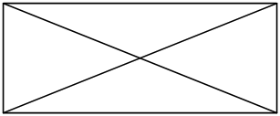 *b)* 

Fig. 1. Image_name *(a)*, image_name *(b)*

Example of a table.

Table 1

Table name

|  |  |  |  |
| --- | --- | --- | --- |
| No. | Parameter 1 | Parameter 2 | Parameter 3 |
| 1 | Text 1 | Value | Value |
| 2 | Text 2 | Value | Value |

Requirements to abstract’s formatting are given below.

**Requirements to abstract’s formatting**:

* File format: DOCX.
* Page format: А4.
* Margins, mm: left 22,5; right 22,5; top 20; bottom 30.
* Font: Times New Roman, 12 pt.
* Line spacing: single.
* Pages per abstract max: 2.
* An abstract should *not* contain the following elements (if possible):
  + A single line equation with a number.
  + Images.
  + Tables.
  + The list of references.

**ORDER OF THE CONTENT APPEARING IN THE ABSTRACT:**

1. Title. Uppercase, centred. Formatting style «Дназв.тез.».
2. Name of author(s). Centred. Formatting style «Дназв.авт.». If authors are representatives of different organizations, then the superscripted “asterisk” symbol patterns (*, ** etc.) are appended after the author's name. Line with the organization name contains the sequence of comma-separated organizations, which are preceded by corresponding superscripted “asterisk” symbol patterns (*, ** etc.).
3. Name of organization(s). Centred. Formatting style «Дназв.орг.».
4. Full Name of author(s) in English followed by the title (in English) after dot. Justified. Formatting style «Днорм.текст» italic. If the abstract’s text is in English, then this item should be omitted.
5. Summary (in English). Justified. Formatting style «Данотація».
6. Main text of abstract. Justified. Formatting styles: «Днорм.текст», «Днорм.текст(без відст.)», «Дсп.нумер.», «Дсп.марк.».

**Creation of the index of names**. To create the index of names in the abstracts the index element (author’s name) should be marked in each abstract. To accomplish this do the following steps:

1. In the “Name of author(s)” line highlight the last name and the first name of the author.
2. Press the “Alt” + “Shift” + “X”.
3. In the «Mark Index Entry» dialog box click the «Mark» button.

Result: there is the MS Word index entry is inserted after the highlighted text. It can be seen after clicking the “Show all” button (“Ctrl” + “Shift” + “8”), look at the screenshot.

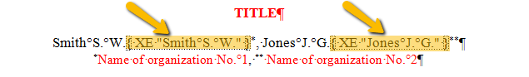

1. Repeat steps 1…3 for each author name.